A.

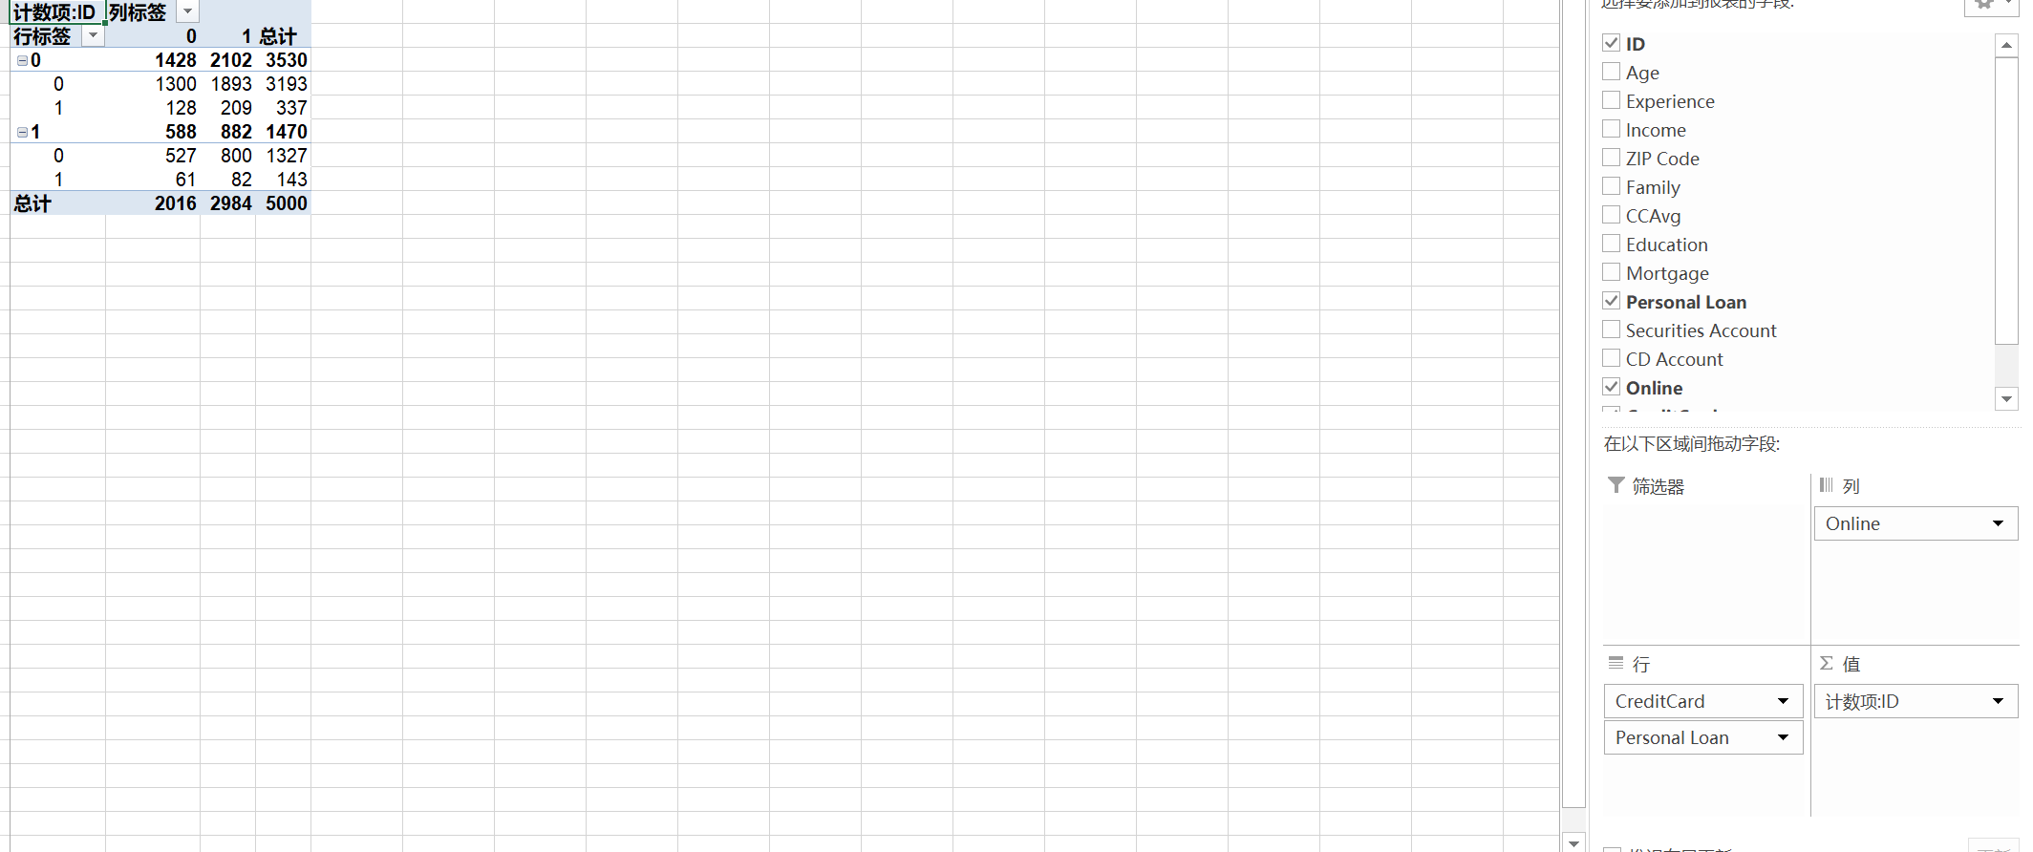

B.

P(Loan=1| CC=1, Online=1)=82/882=9.3%

C.

Loan - Online



Loan - CC

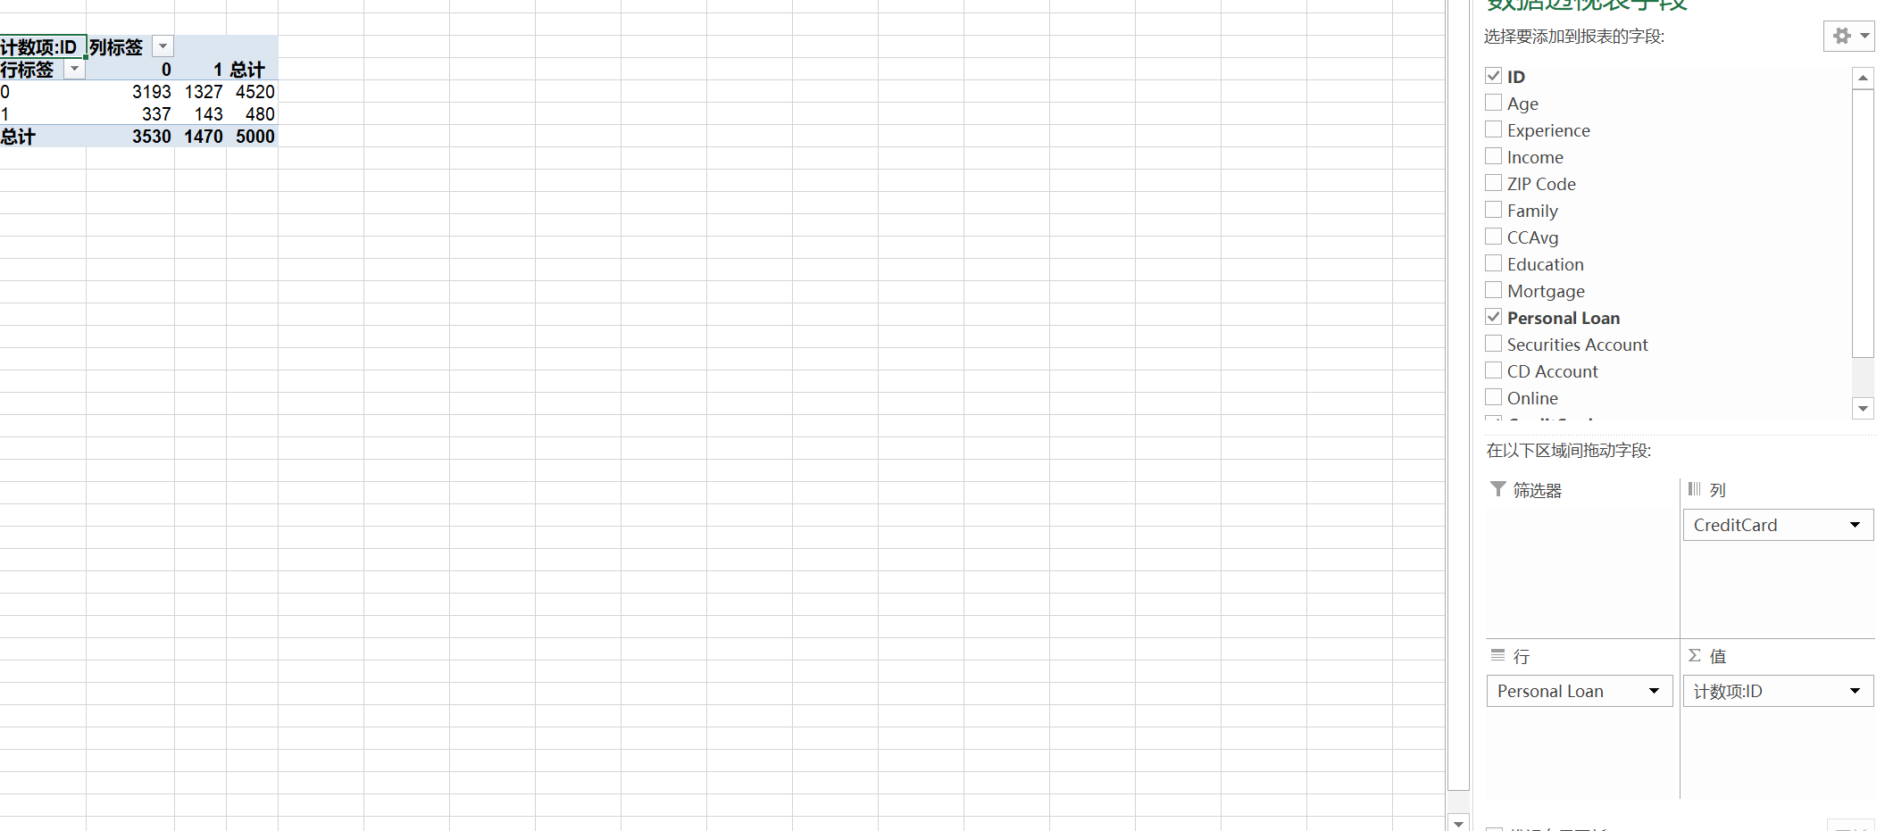

D.

1. 143/480 = 29.8%

Ii) 291/480 = 60.6%

Iii) 480/5000 = 9.6%

Iv) 1327/4520 = 29.4%

V) 2693/4520 = 59.6%

Vi) 4520/5000 = 90.4%

E.

P (loan=1|CC=1, Online=1) = 0.099

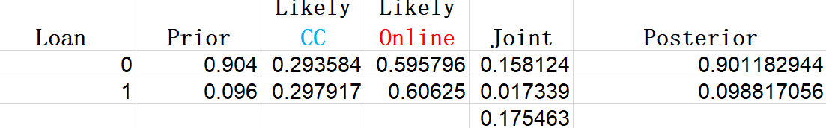

F.

Value from (b), 9.3%

Value from (e), 9.9%

I am not sure.

G.

